Connect SQLite with PowerBI

Connecting SQLite to powerbi requires driver

you can download it with http://www.ch-werner.de/sqliteodbc/ and then click on sqliteodbc_w64.exe

then go to powerbi>get data>more data>search for odbc>select SQLite3 Datasource>specify database location>run query to load data

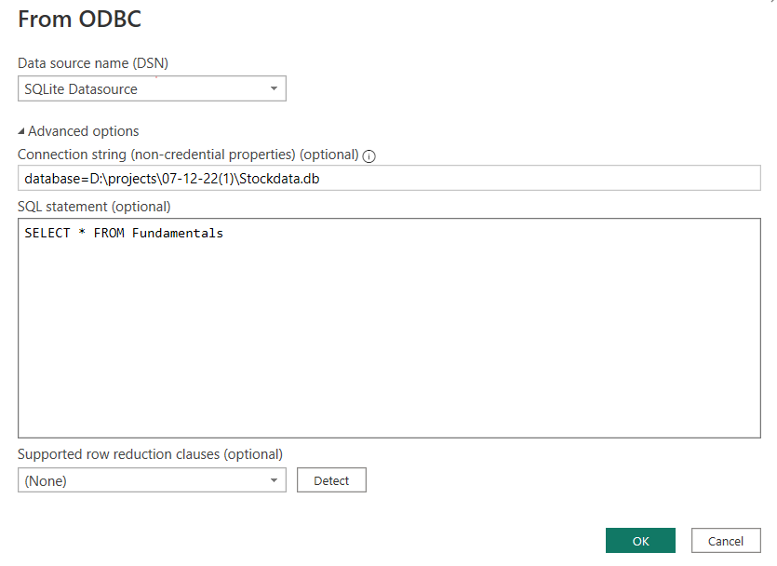

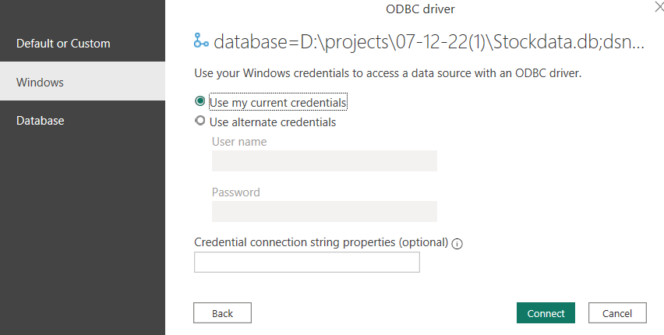

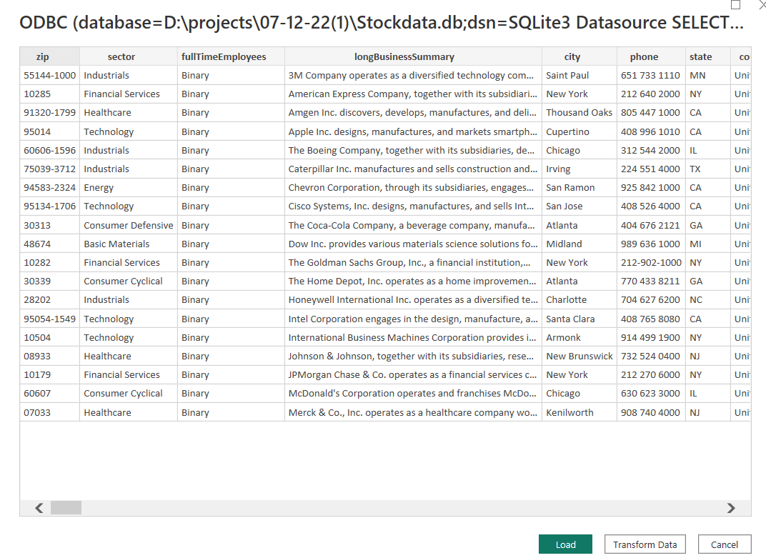

Chart-1

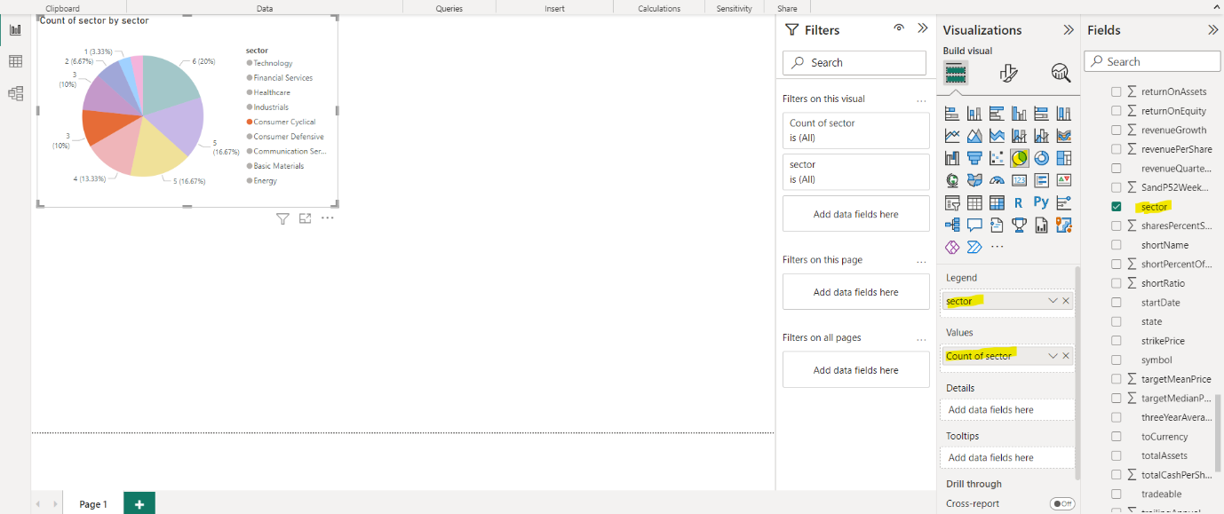

Chart-2

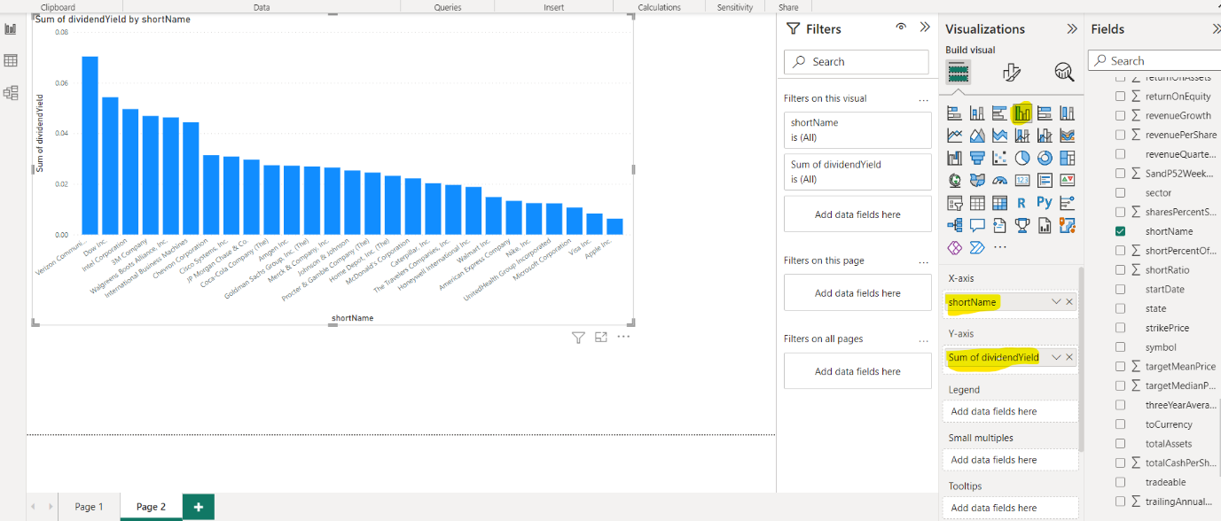

Chart-3

